collaborative filtering

# library link

<https://github.com/scikit-learn/scikit-learn/blob/7e1e6d09b/sklearn/metrics/pairwise.py#L1216>

# basic description

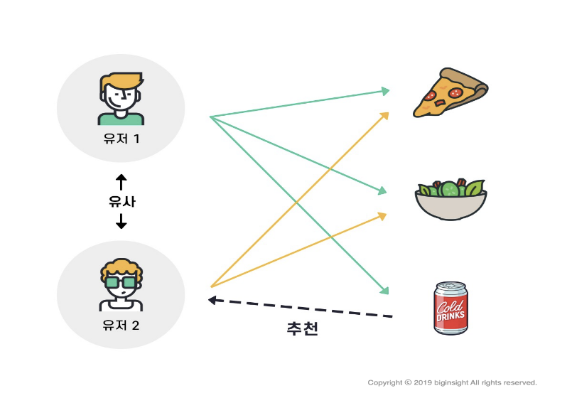

Collabotative filtering is a method that automatically predicts users’ interests according to test information obtained from many users.

User-based recommendation system: A recommendation system for measuring similarity between users.

Item-based recommendation system: A recommendation system for measuring similarity between items.

# version

* numpy >= 1.19.4 (pip install numpy)
* pandas >= 1.0.1 (pip install pandas)
* matplotlib >= 3.1.3 (pip install matplotlib)
* sklearn >= 0.22.1 (pip isntall sklearn)
* seaborn >= 0.10.0 (pip install seaborn)

# dataset

* Movie rating data set 1

<https://www.kaggle.com/tmdb/tmdb-movie-metadata?select=tmdb_5000_movies.csv>

<https://www.kaggle.com/rounakbanik/the-movies-dataset>

* Movie rating data set 2

<https://www.kaggle.com/sengzhaotoo/movielens-small>

# code description

* After downloading the dataset from the moving rating set link, place each dataset in the same location as the code file.
* Item-based recommendation system by measuring the similarity between movie data based on the rating.

# validation

* x